STATEMENT OF CLIENT RIGHTS AND RESPONSIBILITIES

At HVCS, a Division of Cornerstone Family Healthcare ("HVCS"), the client, employees, and all of the professionals involved in a client’s care, communicate with one another and utilize a client-centered approach that aims to empower the client to be an active participant in their health care and improve their overall wellness. HVCS is an anti-racist agency and a safe space for all people.

We believe that a confidential, mutually respected partnership between providers and clients is essential to ensure quality services. Informed consent in understanding your rights and responsibilities as a client of HVCS is central to this partnership. Individuals in need of care will receive the broadest possible array of services, so that their unique needs are met. Participating in this agreement between client and staff provides a reciprocal understanding of one another's rights and responsibilities.

As an HVCS client, you have the right to:
- Receive culturally competent and trauma-informed care from all HVCS employees and volunteers.
- Be informed about the services HVCS provides and the method for obtaining these services.
- A timely response to a request for services provided by HVCS.
- Inclusive services without discrimination on the basis of race, religion, gender identity, national origin, economic status, sexual orientation or physical disability, be provided information and support to work in collaboration with HVCS to create a safe-space.
- Report any form of discrimination to HVCS staff without the fear of retaliation.
- Expect that HVCS will maintain the confidentiality of charts and records pertaining to the services you receive/d, except as otherwise provided by law.
- Decline services and to be informed of any consequences related to your decision.
- Review any records created and maintained by HVCS regarding your services and care.

As a client of HVCS, you have the responsibility:
- To provide accurate and complete information to the best of your ability about current and past health issues, medications (including over-the-counter products and dietary supplements), any allergies or sensitivities, and other matters pertaining to your health and well being.
- To ask questions to make sure you understand your goals, services, or any other aspect of the care you receive from HVCS.
- To keep your appointment, or change or cancel it in a timely manner, to allow others in need to have access to services.
- To be respectful of others, including HVCS staff, volunteers, patients and clients. This includes refraining from language or action that could be perceived as derogatory or racist. Being receptive to information and feedback about cultural awareness to work in collaboration with HVCS in creating a safe-space.
- To communicate with your HVCS staff, Program Supervisor, Assistant Department Director, Departmental Vice President or Associate Vice President of Program Compliance, Quality & Data Management if you have concerns or complaints about the services you receive at HVCS, so we can work together to provide you with the best possible service in the future. You may call your HVCS staff directly or 914.345.8888 and ask for the Program Supervisor, Assistant Department Director, Departmental Vice President or Associate Vice President of Program Compliance, Quality & Data Management to initiate the Grievance process.
- To actively participate in services and work on goals outlined in treatment planning.
- To communicate openly with your HVCS staff and be responsible for the decisions you make when working with HVCS staff.

When a client engages in behaviors which impede the agency’s ability to provide services to the client, or to other clients, suspension of some or all of our services may be necessary. Reasons for suspension or termination may include, but are not limited to the following: Please initial on the line next to each reasoning to show your understanding.

- Aggressive, violent, racist, and/or abusive behavior toward clients, volunteers or staff members.
- Discrimination towards staff members, volunteers, or other clients on the basis of race, religion, gender identity, national origin, economic status, sexual orientation, or physical disability.
- Behavior that infringes on other clients’ ability to benefit from HVCS services.
- Behavior that impedes HVCS' ability to provide services appropriate for the client.

I have received and read the information regarding the statement of client’s rights, informed consent, limits of confidentiality, and complaint/grievance process as an HVCS client. I understand that my consent to services may be withdrawn by me at any time. I understand that my services may be suspended or terminated by HVCS as per the Suspension of Services policy. I understand that signing my name below indicates I have read and been informed of my rights, limits of confidentiality, and complaint/grievance process.

This consent is valid until my consent for service is withdrawn and/or I no longer receive HVCS services.

Client Name: Click here to enter text. Date: Click here to enter a date. Signature of Client or Guardian: Click here to enter text. Date: Click here to enter a date. Witness: Click here to enter text. Date: Click here to enter a date.
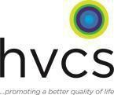
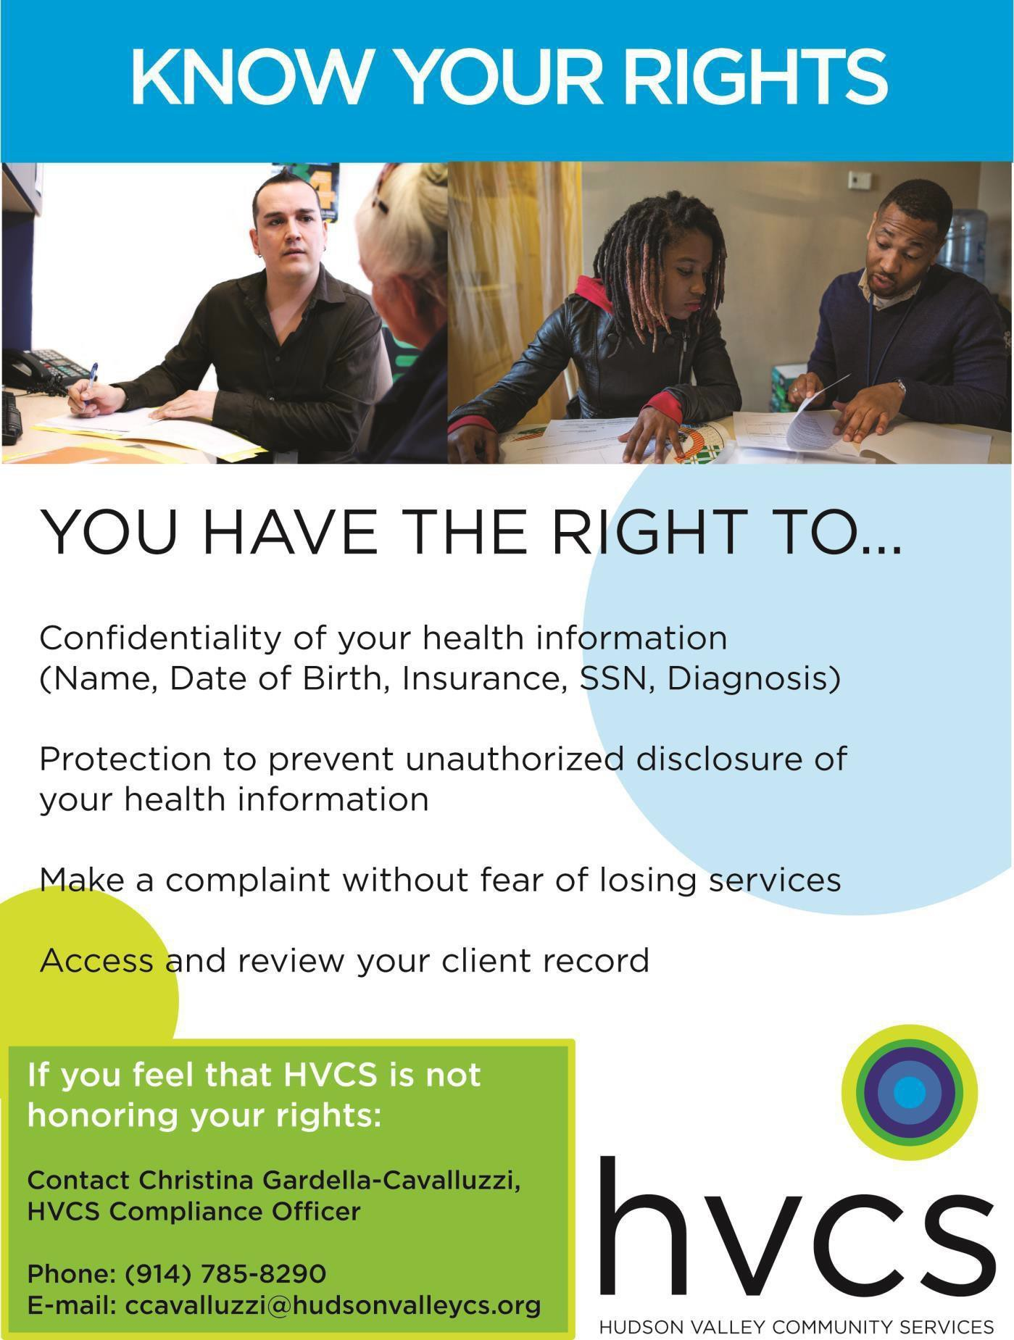
If you feel that HVCS is not honoring your rights:

Contact: Christina Gardella
HVCS Program Compliance Office

Phone: (914) 785-8290
E-mail: cgardella@hudsonvalleycs.org

