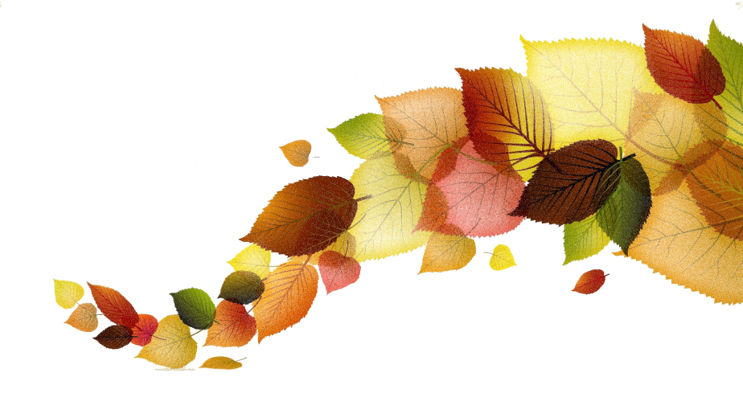
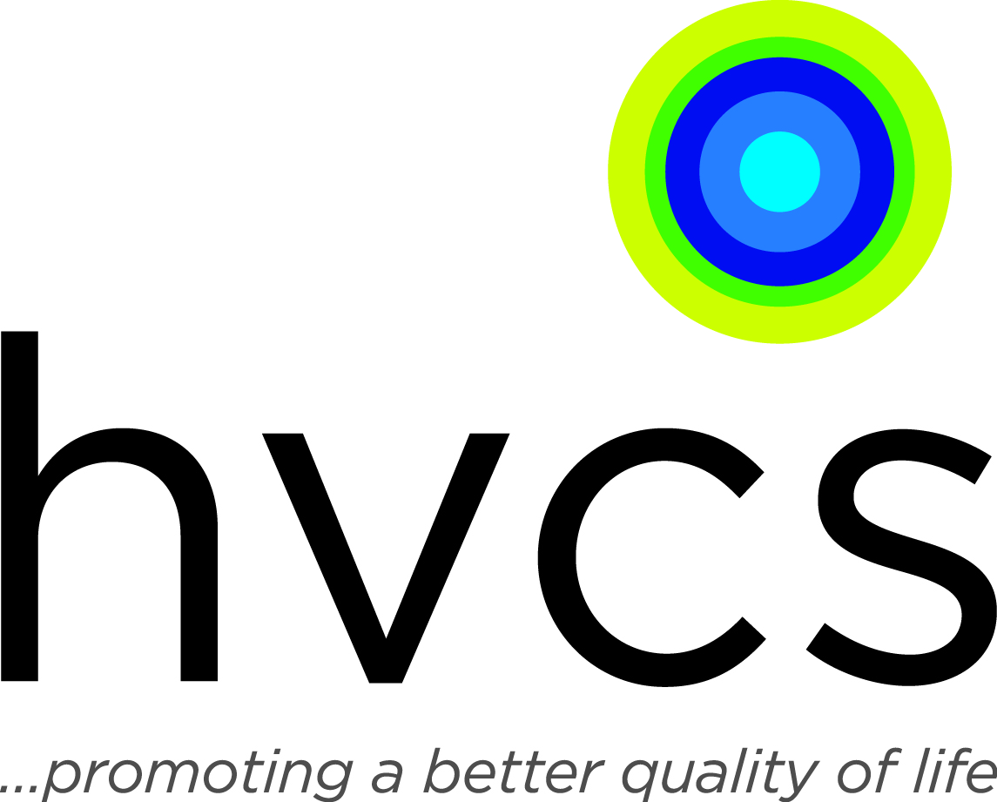

Holiday Food Drive Wish List

Toiletries and Personal Items:

Deodorant
body soap
shampoo
conditioner
moisturizer
shaving cream
toilet paper
toothpaste
toothbrushes

Cleaning Supplies:

laundry detergent
cleaning supplies
paper towel
bleach
dish soap
window cleaner (Windex)
all-purpose cleaner (regular or anti-bacterial)

Non-Perishable Foods:

Canned Fruits
Canned Vegetables
Fruit juice
Boxed dinner items:
potatoes
pasta
macaroni & cheese
tuna
boxed milk (Parmalait)
soups (low sodium preferred)
gravy (low sodium preferred)
beef stew
ravioli
stuffing
cranberry sauce
rice
corn bread mix
canned pumpkin
frozen turkey
canned or frozen ham

